Ross Lewis

425 - Machine Learning – Homework 4

PART 1

Problem I:

I tried three models. The first has 1 hidden layer, uses relu as an activation function, and has a softmax output. The second has 2 hidden layers and uses sigmoid activation and output functions. The last has 3 hidden layers, uses relu as an activation function, and softmax as an output function.

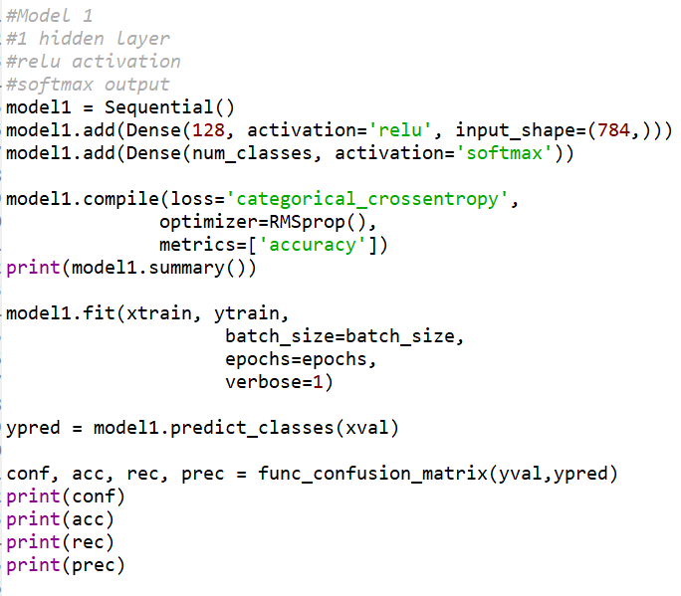

[[ 951 0 1 2 1 0 0 2 3 0]

[ 0 1035 5 0 1 0 0 3 8 2]

[ 1 2 987 6 1 0 2 7 3 1]

[ 1 0 9 1001 2 9 0 5 3 2]

[ 2 0 3 0 1017 0 4 4 1 11]

[ 0 1 1 9 2 852 3 1 6 2]

[ 7 1 2 0 2 3 953 0 6 0]

[ 1 3 4 1 2 0 0 1035 1 6]

[ 4 2 4 7 0 3 0 3 992 3]

[ 1 1 1 6 7 3 0 9 5 947]]

Model 1 accuracy = 0.977

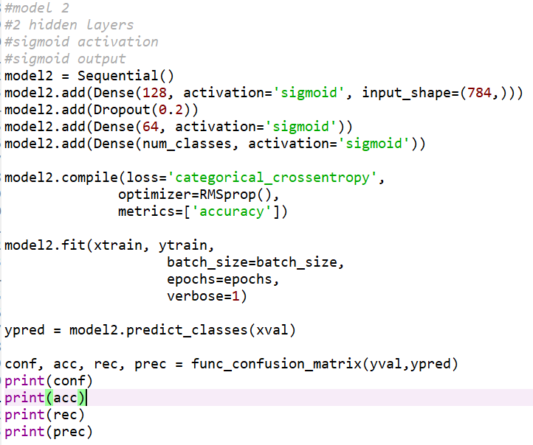

[[ 944 0 1 3 1 2 3 1 5 0]

[ 0 1033 5 1 2 0 0 2 6 5]

[ 2 1 976 6 5 0 5 4 10 1]

[ 2 0 12 975 1 24 0 10 5 3]

[ 3 0 3 0 1007 0 6 3 1 19]

[ 2 3 2 14 3 838 4 2 5 4]

[ 4 2 2 1 2 5 954 0 4 0]

[ 2 6 2 3 1 0 0 1032 0 7]

[ 1 4 7 10 0 5 2 2 983 4]

[ 2 2 1 8 8 4 0 12 8 935]]

Model 2 accuracy = 0.9677

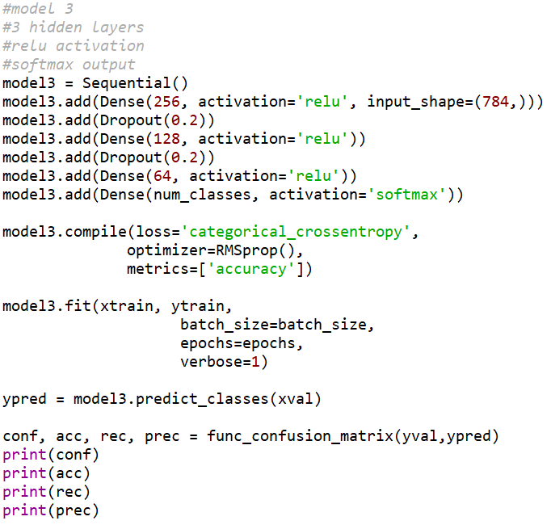

[[ 955 0 2 1 0 0 1 0 1 0]

[ 0 1041 3 0 2 0 1 1 3 3]

[ 2 1 988 8 1 0 2 2 5 1]

[ 0 0 7 1012 0 7 0 2 2 2]

[ 1 0 3 0 1016 0 2 1 1 18]

[ 1 1 1 9 1 857 2 0 3 2]

[ 4 1 1 0 1 3 960 0 4 0]

[ 0 4 0 3 2 0 0 1030 1 13]

[ 1 1 4 10 0 3 0 2 992 5]

[ 1 1 0 3 6 6 0 4 2 957]]

Model 3 accuracy = 0.9808

Model 3 has the best accuracy.

Question II:

Confusion Matrix for model 3 on the test data:

[[ 971 1 1 0 1 1 2 1 2 0]

[ 0 1125 3 1 0 0 2 0 4 0]

[ 0 0 1016 4 2 0 2 4 4 0]

[ 0 0 4 995 0 2 0 4 3 2]

[ 2 0 1 1 958 0 3 1 1 15]

[ 2 0 0 13 1 869 3 0 2 2]

[ 3 2 0 0 3 7 942 0 1 0]

[ 2 6 9 6 1 0 0 988 3 13]

[ 1 1 3 6 1 4 0 2 953 3]

[ 3 2 0 8 4 1 0 1 1 989]]

Accuracy of model 3:

0.9806

Recall of model 3:

[0.99081633 0.99118943 0.98449612 0.98514851 0.97556008 0.97421525

0.98329854 0.96108949 0.97843943 0.98017839]

Precision of model 3:

[0.98678862 0.98944591 0.97974928 0.9622824 0.98661174 0.98303167

0.98742138 0.98701299 0.97843943 0.96582031]

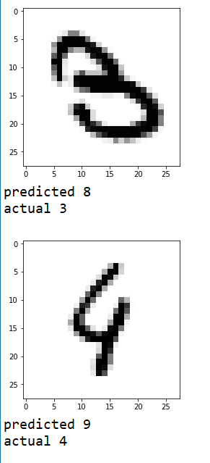

If the lines were connected, the three would look a lot like an 8. Same with the top of the 4 and being similar to a 9.

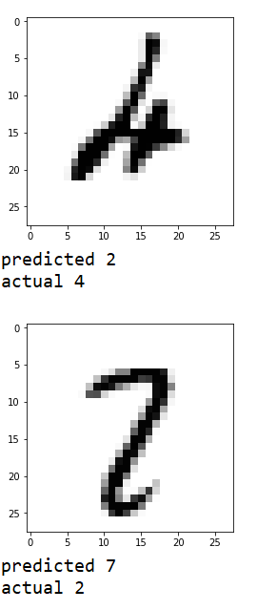

The 4 is quite ambiguous so it would be hard to predict. This 2 looks similar to a 7.

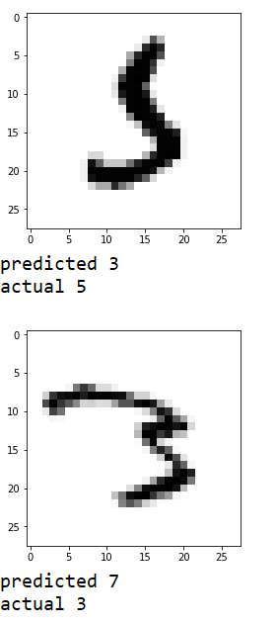

This 5 looks like a 3 without the top part, and this 3 looks like a 7.

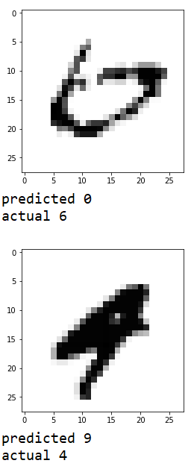

The 6 is almost a 0, and the 4 could be a 9 or a 4.

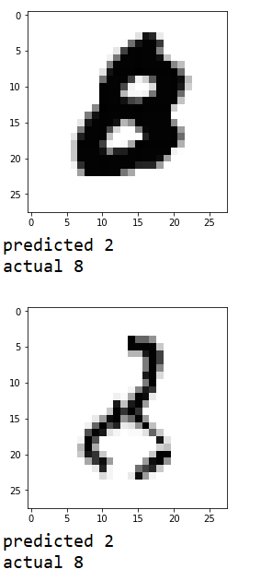

This 8 seems like a bad prediction, but the bottom 8 isn’t even drawn well.

PART 2

A C value of 5 looks like it is the best for this data.

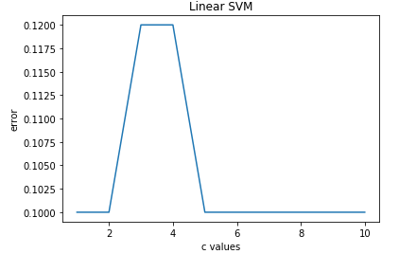

Linear performs better than poly and rbf.

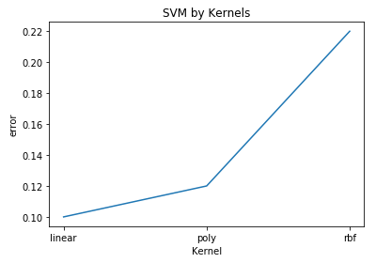

Metrics for the test set:

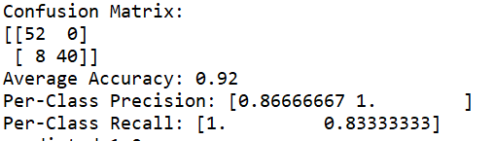

Here are 5 incorrect predictions and 5 correct predictions. Correct predictions tend to have more extreme value features where the incorrect predictions are in the middle.

predicted 1.0

actual -1.0

data [ 1. 11.1 9.9 23.8 27.1 9.8]

predicted 1.0

actual -1.0

data [ 1. 12.3 11. 26.8 31.5 11.4]

predicted 1.0

actual -1.0

data [ 1. 9.2 7.8 19. 22.4 7.7]

predicted 1.0

actual -1.0

data [ 0. 9.1 6.9 16.7 18.6 7.4]

predicted 1.0

actual -1.0

data [ 1. 12.8 10.9 27.4 31.5 11. ]

predicted -1.0

actual -1.0

data [ 1. 13.9 11.1 29.2 33.3 12.1]

predicted -1.0

actual -1.0

data [ 1. 19.8 14.2 43.2 49.7 18.6]

predicted -1.0

actual -1.0

data [ 1. 19.7 15.3 41.9 48.5 17.8]

predicted 1.0

actual 1.0

data [ 1. 14.7 12.5 30.1 34.7 12.5]

predicted 1.0

actual 1.0

data [ 0. 15.7 13.6 31. 34.8 13.8]